# 

# 

# 

# 

# 

UNICORN Sales Data Analysis

# **Executive Summary**

## Team Members

Sultan Mahmood Riaz

Svitlana Kovalivska

Solomon Appiah Kubi

Biiyana Jüngling

Anthony Godwin Edoro

Sumi Dhakal

## Links

[SQL findings](https://docs.google.com/document/d/1QK5sebbohI2-JILJ8jC7neeFrIruo_dhpLrHkI25BBk/edit?usp=sharing),

[Spreadsheet findings](https://docs.google.com/spreadsheets/d/1cS2akiHp_s0Botnv0bD8PKsqSel6zgfKY4mp1fO_qG4/edit?usp=sharing),

[Tableau Dashboard](https://public.tableau.com/views/UNICORNProjectDashboard/DashboardLastverson?:language=en-US&:sid=&:redirect=auth&:display_count=n&:origin=viz_share_link),

[Presentation](https://docs.google.com/presentation/d/1ozJY38RFj7pVva1gI5n4o2yIJNuSFM3p6CuC5U_LVYI/edit?usp=sharing),

[Video](https://www.loom.com/share/8fd9e0626ec449eeb37987b6b215152f?sid=d7fe5045-4595-47cc-858d-a4392197b747),

[Additional Business Metrics](https://docs.google.com/document/d/10OEKCm9O9ZGEyRZnloqLEa55Bpl_zJSr/edit?usp=sharing&ouid=104839883381711349061&rtpof=true&sd=true)

### 

### 

### **Project Overview**

### This project analyzed Unicorn's sales data to uncover insights for business growth. We examined trends in customer behavior, product performance, and regional profitability using Google Sheets, SQL, and Tableau for analysis.

### **Approach to Data**

### **Data Cleaning:** Extensive cleaning was done to ensure data accuracy, including adjustments to the Profit Rate based on formulas and assumptions.

### **Assumptions:** We assumed that Profit, Sales, Quantity Discount and other variables were clearly defined.

### 

### **Problem Statement:**

### **High Customer Count but Low Profitability:**

### Cities like Houston, Philadelphia, Dallas and Chicago, despite having more than 77 customers, still in loss, while New York shows the highest profitability. There's a clear gap in profit per customer, from New York's (**$62.019**) to Philadelphia's (**$-13.832**).

### 

### **Key Insights**

* **Seasonal Sales, Low Profit Growth**: December sees a sales spike(**$35.568)**, but profit doesn’t grow proportionally, likely due to high discounts(**>29%**), and lower-margin products.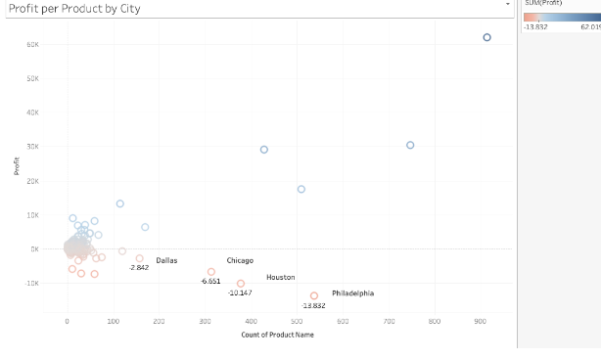
* **Discounts Affect Profitability**: Discounts above **30%** affects profitability, especially in the Furniture and Office Supplies categories. Despite a modest **0.3%** discount on Tables and Binders, profits are negative.
* **Delivery Impact on Profit**: Longer delivery in states like Pennsylvania, Ohio, and Florida influence on profitability, particularly for **Tables**, where shipping delays beyond **5** days increase costs and reduce customer satisfaction.
* **Products sold by almost all Manufacturers in selected Subcategories are unprofitable.** That issue may be related to pricing, production costs, or quality of products.

### **Recommendations**

* **Focus on Profitability of Cities**: Unicorn should rethink its approach to loss-making cities with high customer counts, such as Houston, Philadelphia, Dallas and Chicago. Conduct market segmentation to tailor strategies and boost profitability.
* **Optimize Product and Delivery Strategy**: Improve delivery times in targeted regions and consider expanding product offerings for the underperforming Furniture category to capture more market share.
* **Enhance Seasonal Strategy**: Maximize sales in Quarter 4 with promotions, while analyzing why increased revenue doesn't translate into higher profits.
* **Refine Discount Policy**: Limit discounts to 30% or less for the most sensitive categories and consider tiered discounts for lower-demand products.
* Establish a **Quality-Based Supplier Optimization Program** focused on improving the profitability.

### **Conclusion:** Unicorn should prioritise regional expansion, focus on optimising the product, discount strategies, and improve delivery efficiency. By addressing issues such as shipping times, excessive discounts and operational inefficiencies, profitability and customer satisfaction can be enhanced.